LAB 8A

CODE

*//*

*// newLAB.cpp*

*// newlab*

*//*

*// Created by Ricardo Santos on 4/22/19.*

*// Copyright © 2019 Ricardo Santos . All rights reserved.*

*//*

#include "newLAB.hpp"

#include <iostream>

**using** **namespace** std;

**int** main()

{

**int** num1; *// holds 1st number*

**int** num2; *// holds 2nd number*

**int** result; *// holds result of multiplication*

**int** *num1Ptr = **nullptr**; *// int pointer which will be set to point to the 1st number*

**int** *num2Ptr = **nullptr**; *// int pointer which will be set to point to the 2nd number*

cout << "Please input the 1st number" << endl;

cin >> num1;

cout << "Please input the 2nd number" << endl;

cin >> num2;

num1Ptr = &num1;

num2Ptr = &num2;

*// Fill in code to make num1Ptr point to num1 (hold its address)*

*// Fill in code to make num2Ptr point to num2 (hold its address)*

result = *num1Ptr * *num2Ptr; *// Fill in code to find the result (of multiplying the 2 numbers) by using only the pointer variables*

cout << "The result is " << result << endl;

**if** (*num1Ptr > *num2Ptr)*// Fill in the condition num1 > num2 by using only the pointer variables)*

cout << "The 1st number is greater than the 2nd number" << endl;

**else** **if** (*num2Ptr > *num1Ptr)*// Fill in the condition of num2 > num1 by using only the pointer variables)*

cout << "The 2nd number is greater than the 1st number" << endl;

**else**

cout << "The 2nd number and 1st number are the same" << endl;

**return** 0;

output

}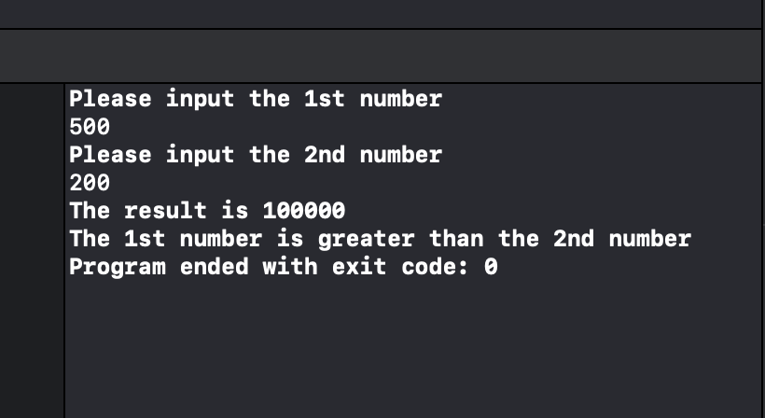 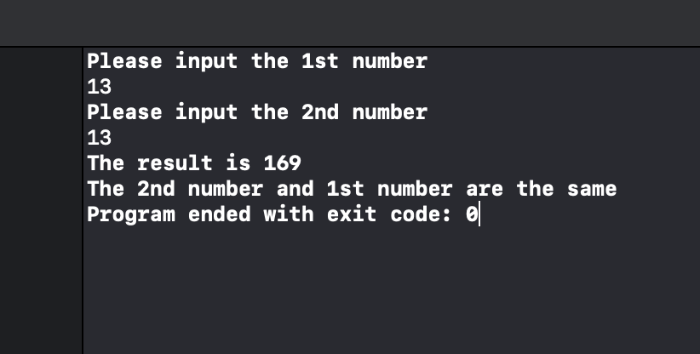 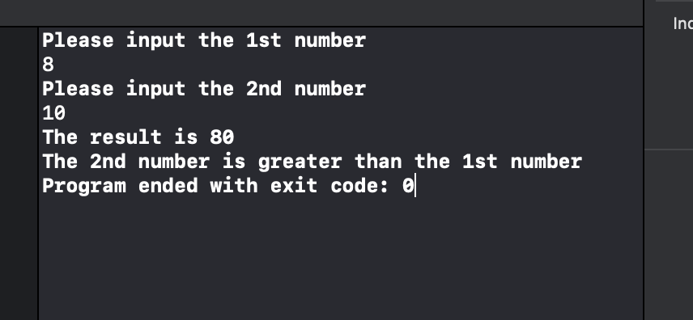

LAB 8B

CODE

*//*

*// newLAB.cpp*

*// newlab*

*//*

*// Created by Ricardo Santos on 4/22/19.*

*// Copyright © 2019 Ricardo Santos . All rights reserved.*

*//*

#include "newLAB.hpp"

#include <iostream>

#include <iomanip>

**using** **namespace** std;

**int** main()

{

**double** *tempavgptr = **nullptr**;

**int** **const** SIZE = 7;

**double** avgtemp[SIZE] = {75.2, 76.8, 80.2, 90, 85.7, 84.3, 70.3};

**int** index;

**double** total = 0;

**double** calcAVG;

tempavgptr = avgtemp;

**for**(index = 0; index < SIZE; index++)

{

cout << "The average temperature for the " << (index + 1) << " day of the week is: \n";

cout << (*tempavgptr + index) << endl;

}

**for**(**int** i = 0; i < 7; i++)

{

total += *(tempavgptr + (i));

}

calcAVG = total / SIZE;

cout << fixed << showpoint << setprecision(2);

cout << "The average daily temperature for a week in June is: " << calcAVG << endl;

**return** 0;

}

OUTPUT

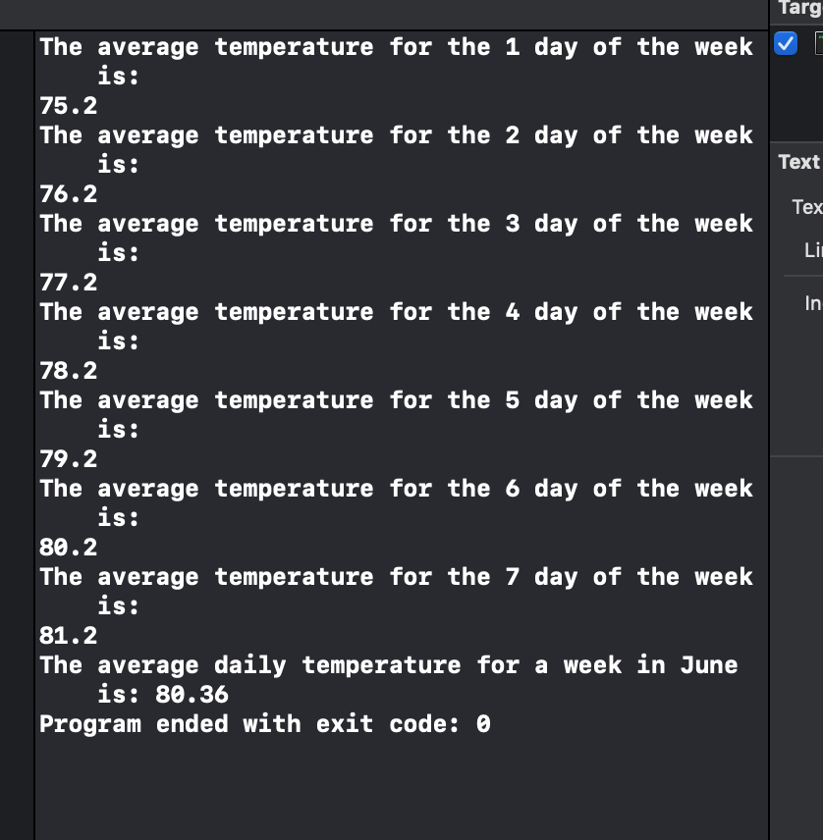

LAB 8C

**Code**

*//*

*// 8C.cpp*

*// 8C*

*//*

*// Created by Ricardo Santos on 4/25/19.*

*// Copyright © 2019 Ricardo Santos . All rights reserved.*

*//*

#include "8C.hpp"

#include <iostream>

#include <iomanip>

**using** **namespace** std;

**int** **const** SIZE = 7;

**int** **const** SIZE2 = 6;

**void** tenpercent(**int** *, **int**, **int** *, **int**);

**void** finddifference(**int** *, **int**, **int** *, **int**);

**int** main()

{

**int** salaryInput[SIZE];

**int** *Inputsalaryptr = **nullptr**;

**int** *Inputsalaryptr2 = **nullptr**;

**int** salaryInput2[SIZE];

Inputsalaryptr = salaryInput;

Inputsalaryptr2 = salaryInput2;

cout << "Enter the salaries for employees.\n";

**for**(**int** i = 0; i < SIZE2; i++)

{

cout << "Enter salary for employee number " << i + 1<< endl;

cin >> *(Inputsalaryptr + i);

**if**(*(Inputsalaryptr + i) <= 0)

{

cout << "Invalid entry. input can not be 0 or negative!\n";

cout << "Enter salary for employee number " << i + 1<< endl;

cin >> *(Inputsalaryptr + i);

}

}

*//float added;*

tenpercent(Inputsalaryptr, SIZE, Inputsalaryptr2, SIZE);

finddifference(Inputsalaryptr, SIZE, Inputsalaryptr2, SIZE);

}

**void** tenpercent(**int** *salary1, **int** sizes, **int** *salary2, **int** sizes2)

{

**for**(**int** i = 0; i < SIZE; i++)

{

salary2[i] = (salary1[i] * .1) + salary1[i];

}

}

**void** finddifference(**int** *ptr1, **int** sizes3, **int** *ptr2, **int** sizes4)

{

**int** sum = 0;

**int** ptr3[SIZE];

**for**(**int** i = 0; i <= SIZE; i++)

{

ptr3[i] = *(ptr2 + (i)) - *(ptr1 + (i));

*//sum += ptr3[i];*

sum += ptr3[i];

}

**for**(**int** i = 0; i < SIZE2; i++)

{

cout << "The original salary for employee number " << i + 1 << " is:\n";

cout << *(ptr1 + (i)) << endl;

cout << "The salary with the added 10 percent increase for employee number " << i + 1 << " is:\n";

cout << *(ptr2 + (i)) << endl;

}

cout << "The sum of the difference between the original salaries and the salaries with the added 10 percent increase is: \n";

cout << sum << endl;

}

**Output**

 